16.48: The altitude of the plane when it passes over the end of the runway is , and so the sound intensity is 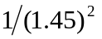 of what the intensity would be at 100 m. The intensity level is then

so the airliner is not in violation of the ordinance.

